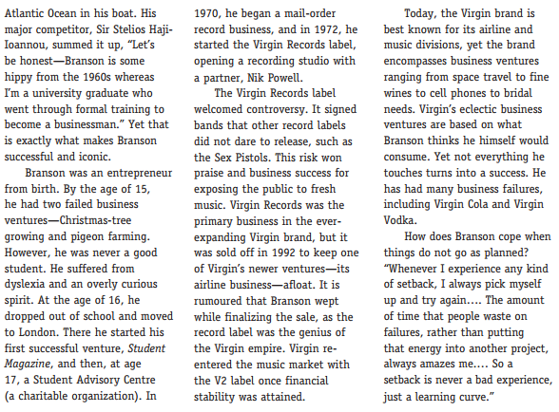
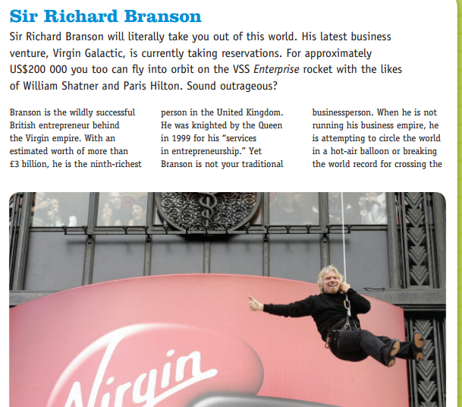
Questions
- Describe Sir Richard Branson, his characteristics, and what you think makes him a successful businessperson.

- Why do you think people say that failure is an important ingredient in becoming a better entrepreneur?

