EMS3O Unit 2
MEDIA VIOLENCE: HAS TELEVISION CROSSED THE LINE?

CASE STUDY: THE CW’s ONE TREE HILL and 90210
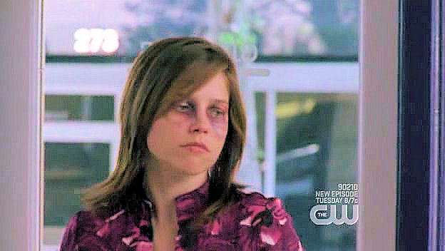

Television networks have become obsessed with ratings and will do anything to fill the number one spot. Violence, sex, and money have slowly leaked into everyday television over the past few decades. In today’s media environment notions of violence, sex and money seem to have saturated our television programming. The rampant use of this kind of risqué content is crucial for the survival of most, if not all, television programs. If networks desire to stay on top they have to be able to compete with all of the other explicit television programs already out there. What does this violent and rated R content mean for the youth of America?
As the American Psychiatric Association sates, “…people who watch a lot of television are more likely than those who watch less to see the world as being violent and overestimate their chance of being involved in violence.” Society’s view of reality is being distorted through television shows. This misrepresentation of reality can be seen in programming like the CW’s One Tree Hill and 90210.
The major networks are constantly pushing the envelope in order to make their television shows more entertaining. One Tree Hill started out like any normal teenage program. It was based around the struggles of high school and the pettiness that goes along with growing up. However, as the series continues to progress, the storylines have intensified. In six short seasons the producers and writers have managed to form plots around physical abuse, murder, stalking, teen pregnancy, kidnapping, torture, and a school shooting. Keep in mind that this show airs during primetime television jumping back and forth from the eight o’clock spot to the nine o’clock spot over the course of the series. This highly watched time slot, while late enough to avoid most young children is still widely watched by the 12-18 demographic.
According to the Parents Television Council, “TV violence has become a paradox of sorts. Medical and social science have proven conclusively that children are adversely affected by exposure to it… Despite the widespread consensus that TV violence is a significant problem, it has become not only more frequent, but more graphic in recent years.”
The CW added 90210 to their Fall 2008 line-up as a revamped version of the old smash hit that was popular in the 1990’s. 90210 is a great example of how new television shows are forced to push the envelope with excessive sex and violence in order to compete with the existing shows already out there. It’s currently still in its first season, yet the writers and producers have already managed to jam pack the show with an abundant amount of drama, violence, sex and money.
Most of the teenagers that go to school at Beverly Hills High School drive expensive cars, live in extravagant mansions, party and drink all the time, and are absolutely gorgeous. If we let our reality be distorted from watching these shows we would then believe that most people live these kinds of flashy and lavish lifestyles. In only nineteen episodes, viewers have already been exposed to teen pregnancy, alcohol and drug addictions, bi-polar disorder, adultery, and drag racing. The fact that they have already incorporated this much violence and sexual content into their first season makes one wonder– what’s next for season two?
While television shows like 90210 attempt to stay relevant by focusing on real issues, they are misleading their viewers. It isn’t typical that the TV characters we have come to identify with could actually experience so many of these issues personally and directly. Sometimes a character goes through so many emotionally charged incidents that we are led to believe that this person can carry on normally. Yet in actuality if one person had experienced the same amount of traumatizing events they would need intensive psychiatric care.
The Parents Television Council has proposed a few solutions to halt and even decrease the amount of violence on primetime television. “Advertisers... using their unique position of influence, can encourage broadcasters to reduce the frequency and explicitness of TV violence. Broadcast affiliates, too, can play a role by preempting excessively violent programs and refusing to air violent programs in syndication during times of day when children are watching TV.” Is there any motivation for advertisers to put pressure on broadcasters to reduce their violent and sexual content? If advertisers and other influential participators can put enough pressure on these broadcasters, TV violence would significantly decrease?
Viewers have become desensitized to this type of violent and R-rated programming. Will television programs continue to exist if the controversial content was toned down and television shows were forced to illustrate scenarios more closely in line with reality?

Discussion:
Think about your favorite primetime television show. Choose a character from this show and formulate a list of all the things that have happened to this specific character, traumatizing and/or rewarding. Keep in mind:
• The age of the character you chose
• The length of time that has passed between each event or happening
• The way the character reacted to each scenario
• How long it took for the character to recover from the issue at hand
After you have completed the list, think about your own life. Make a list of all the things that have happened to you over the years, traumatizing and/or extremely rewarding.
Compare your own list to that of the fictional character. Consider these questions when you make your comparison:
1. Have you experienced as many upsetting events as the fictional character you chose?
2. Do you believe it is likely that the fictional character you chose could actually go through all of the things he or she has over the course of the show in real life?
3. Are any of the events your fictional character went through similar or the same as events you have gone through in your life?
4. If so, do you feel these events were accurately portrayed on the television show?

